MiSACWIS Project

PM01a – Maintain Additional Name Screen Specification
Version 1.5

June 22, 2016

Prepared for:


120 N. Washington Square
SACWIS Project, 3rd Floor
Lansing, MI 48933

Prepared by:

Revision Log
Version | Date | A/D/C (Add, Delete, Change) | Author | Document Section # | Description
0.1 | 08/09/2011 |  | P. Rasher |  | Initial version
1.0 | 09/21/2011 |  | P. Rasher |  | Approved
1.1 | 09/21/2011 | C | P. Rasher | 3.1.3 | Quality Assurance Review  Section 3.1.3  No functionality impact. Updated information highlighted in yellow.
1.2 | 09/22/2011 | C | K. Stone | 2.1.3  1.1 | Changed Security Requirements  Added detail to the purpose statement  No functionality  changes
1.3 | 11/04/2011 | A | K. Stone | Purpose | Added detail to the purpose statement
1.4 | 11/08/2011 | C | K. Stone | 1.2 | Added detail to the purpose statement.
1.5 | 06/22/2016 | C | M. Van Hoose | 3.1.2, 3.1.3, 3.1.5 | CQ# 110957
Table of Contents
1 Introduction 5
1.1 Purpose 5
1.2 Scope 5
2 Use Case Details 6
2.1.1 Action Buttons/Hyperlinks 6
2.1.2 Business Rules 6
2.1.3 Security Requirements 7
2.1.4 Screen Navigation 8
2.1.5 Tab Order 8
2.1.6 Pre-Conditions 8
2.1.7 Ticklers 9
2.1.8 Notifications 9
2.1.9 Calendar 9
2.1.10 Reports 10
2.1.11 Notes and Assumptions 10
3 Screen Details 11
3.1 S01 – Add Additional Name Screen 11
3.1.1 As Is – Screen Mock Up 11
3.1.2 To Be – Screen Mock Up 11
3.1.3 Screen Fields 12
3.1.4 Action Buttons 13
3.1.5 Business Rules 13
3.1.6 Screen Navigation 13
3.1.7 Pre-Conditions 13
3.1.8 Notes and Assumptions 13
3.1.9 Reference Values 13

List of Figures
Figure 1 – Add Additional Name Screen – Existing Screen Mock Up 11

Introduction

Purpose
This is a use case regarding the business entity “Maintain Additional Name” which is a sub-use case of PM01 – Maintain Person Profile. The Maintain Additional Name processing creates and maintains Additional Names in the MiSACWIS database.

Scope
The PM01a-Maintain Additional Name allows authorized users the ability to record additional names associated with a person. During the course of the case life cycle, users may become aware of aliases, name changes, or AKA (also known as) names. Maintain additional name allows the worker to record this information and associate it with the person record.
Authorized users access PM01a-Maintain Additional Name by first executing CF54-Find a Person or by selecting a person who is already included in a work item (e.g. a Case record) or work item task (e.g. Investigation record). After the user selects the appropriate Person record, MiSACWIS displays PM01i-View Person Overview. From this point, the user selects the Person Profile hyperlink to gain access to the Basic page. Through the Basic page, users can add/update/view additional names information. Additional Name information can be used as search criteria when performing person searches through the CF54-Find a Person functionality.
- Use Case Details

    - Action Buttons/Hyperlinks
Status (Keep/Add/Modify/Delete) | Label | Type | On Click Action/Navigation
Keep | Save | Button | Current screen data will be cached. All cached screen data will be committed to the database.
Keep | Cancel | Button | All cached screen data will be erased. All fields will be re-initialized.
Keep | Help | Hyperlink | Screen-level help will appear in a separate browser window.
    - Business Rules
No. | Status (Keep/Add/Modify/Delete) | Business Rule Description | Modified Business Rule Description | Execution Event (field tab out/save etc) | Error Msg Code  To be completed by Development Team
1 | Remove | First and Last name fields are required when this page is launched | N/A
2 | Keep | When adding ADDITIONAL NAME Type “Alias”, system will require the addition of only one of First, Middle Name 1, or Last name.
4 | Keep | Only one “verified” name type may exist.
5 | Keep | Only one “reported” name type may exist.
6 | Keep | “Verified” name type and “Reported” name type may not concurrently exist.
7 | Keep | Any number of “Alias” name types may exist concurrently with any other name type.
8 | Keep | Any number of “Married” name types may exist concurrently with any other name type.
9 | Keep | Only one “Maiden” name type may exist.
    - Security Requirements
No. | Status (Keep/Add/Modify/Delete) | Security Requirement
1 | Keep | Worker  - Create  - Read  - Update  - Delete
    - Screen Navigation
No. | Status (Keep/Add/Modify/Delete) | To Screen Navigation Path
1 | Keep | Worker must click “Add Additional Name” button.
2 | Keep | Additional Name details may be launched by clicking “select” in a corresponding row, if an additional name already exists.
    - Tab Order
No. | Status (Keep/Add/Modify/Delete) | Screen name
    - Pre-Conditions
No. | Status (Keep/Add/Modify/Delete) | Pre-Condition
1 | Add | Create – The person record exists.  Read – The person record exists. Additional Name has been added.  Update – The person record exists. Additional Name has been added.  Delete – The person record exists. Additional Name has been added.
    - Ticklers
Status (Keep/Add/Modify/Delete) | Tickler Name | Trigger Action | Tickler Generation Business Rule & Description | Tickler Removal Business Rule | Tickler Text
Status (Keep/Add/Modify/Delete) | Tickler Role
 | N/A
    - Notifications
Status (Keep/Add/Modify/Delete) | Notification Name | Trigger Action | Message Business Rule & Description | Message Text
Status (Keep/Add/Modify/Delete) | Notification Role | Trigger Action | Message Business Rule & Description | Message Text
 | N/A
    - Calendar
Status (Keep/Add/Modify/Delete) | Calendar Name | Trigger Action | Calendar Event Generation Business Rule & Description | Calendar Event Date and Time Business Rule | Calendar Event Text
Status (Keep/Add/Modify/Delete) | Calendar Role
 | N/A
    - Reports
    - Notes and Assumptions

Screen Details

S01 – Add Additional Name Screen

As Is – Screen Mock Up
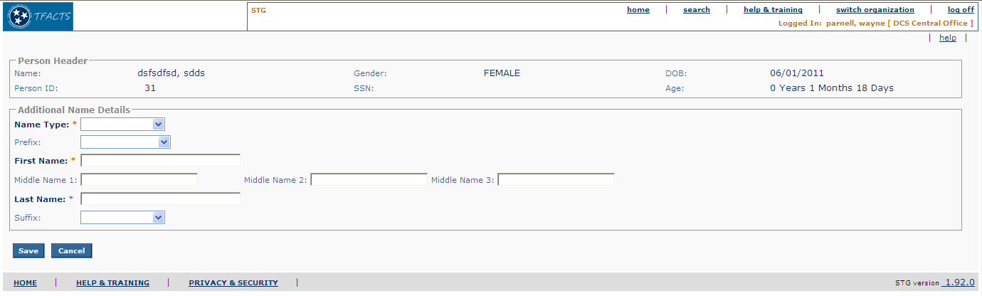
Figure 1 – Add Additional Name Screen – Existing Screen Mock Up

To Be – Screen Mock Up

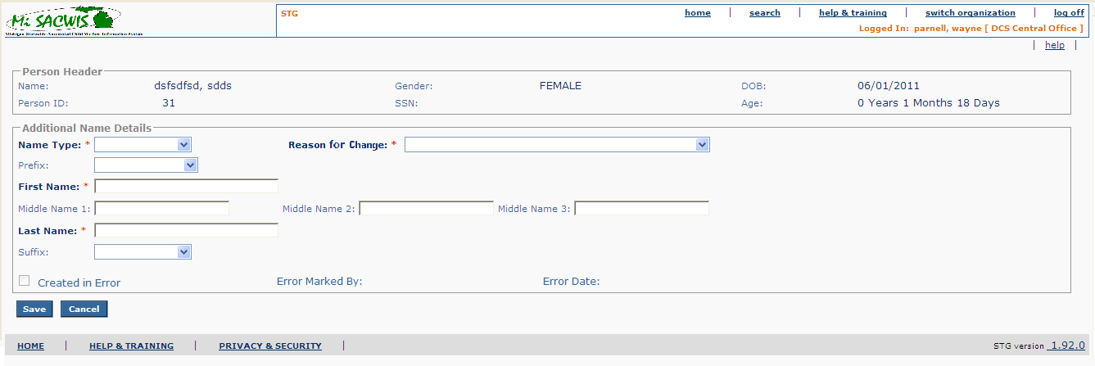
Figure 2 – Add Additional Name Screen – Updated Screen Mock Up

Screen Fields
Status (Keep/Add/Modify/Delete) | As Is  Class.Attribute Name | To Be  Class.Attribute Name | As Is  Display Name | To Be  Display Name | To Be  Type | To Be  Align | To Be Size | To Be  Read  Only | To Be  Calculation | To Be  Edit Mask | To Be  UI Validation
Keep | N/A | N/A | Person Header | Person Header | Section Header
Keep | Person.lastName + Person.firstName + Person.middleName | Person.lastName + + Person.suffixCode + Person.firstName + Person.middleName | Name | Name | Display Text | L | 100 | T |  | Last Name, Suffix Code, First Name  Middle Name
Keep | Person.personID | Person.personID | Person ID | Person ID | Display Text | L | 30 | T
Keep | Person.SSN | Person.SSN | SSN | SSN | Display Text | C | 11 | T |  | ###-##-####
Keep | Person.birthDate | Person.birthDate | DOB | DOB | Display Text | C | 7 | T |  | MM/DD/YYYY
Keep | Person.genderCode | Person.genderCode | Gender | Gender | Display Text | R | 30 | T | Use Short Desc from Ref Data where Domain Category = ‘Gender'
Keep |  |  | Age | Age | Display Text | R | 30 | T | Subtract Person.birthDate from System Date | ### Years  ## Months  ### Days
Keep | N/A | N/A | Additional Name Details | Additional Name Details | Label
Keep | AKA.akaNameType | AKA.akaNameType | Name Type: | Name Type: | Drop down List | L | 100 | F | Domain code = nameType |  | User selected  Required  Default to null
Add | N/A | AKA.changeReasonCode | N/A | Reason for Change | Drop down List | L | 75 | F | Domain Code = ‘NameReplacedReason’ | N/A | User selected  Not Required
Keep | AKA.akaPrefixCode | AKA.akaPrefixCode | Prefix | Prefix | Drop Down List | L | 100 | F | Domain code = Prefix |  | User selected  Not Required
Keep | AKA.akaFirstName | AKA.akaFirstName | First Name | First Name | Text Field | L | 25 | F |  |  | User entered  Required
Keep | AKA.akaMiddleName | AKA.akaMiddleName | Middle Name 1 | Middle Name 1 | Text Field | L | 25 | F |  |  | User entered  Not required  Enable Middle Name 2 if not null
Keep | AKA.akaMiddleName2 | AKA.akaMiddleName2 | Middle Name 2 | Middle Name 2 | Text Field | L | 25 | F |  |  | User entered  Not required  Enable Middle Name 3 if not null
Keep | AKA.akaMiddleName3 | AKA.akaMiddleName3 | Middle Name 3 | Middle Name 3 | Text Field | L | 25 | F |  |  | User entered  Not required
Keep | AKA.akaLastName | AKA.akaLastName | Last Name | Last Name | Text Field | L | 35 | F |  |  | User entered  Required
Keep | AKA.akaSuffixCode | AKA.akaSuffixCode | Suffix | Suffix | Drop down list | L | 100 | F | Domain Code = Suffix |  | User selected  Not required
Add | N/A | AKA.createdInErrorFlag | N/A | Created in Error | Check Box | N/A | N/A | F | N/A | N/A | User selected  Not required
Add | N/A | AKA.modifiedBy | N/A | Error Marked By | Display Text | L | N/A | T | N/A | N/A | N/A
Add | N/A | AKA.modifiedDate | N/A | Error Date | Display Text | L | N/A | T | N/A | N/A | N/A

Action Buttons
Status (Keep/Add/Modify/Delete) | Label | Type | On Click Action/Navigation | Tab Order

Business Rules
No. | Status (Keep/Add/Modify/Delete) | Business Rule Description | Execution Event (field tab out/save etc) | Error Msg Code  To be completed by Development Team
1 | Add | If the Additional Name record is created-in-error, everything on this screen should be read only. | Screen Display
2 | Add | When this screen presented because the user clicked select from the Person Detail screen, if the Name Type = ‘Previous Name’ everything other than the Created in Error check box will be read only. | Screen Display
3 | Add | The word unknown is not allowed to be a part of First Name, Middle Name 1, Middle Name 2, Middle Name 3, or Last Name. | Save Button

Screen Navigation
No. | Status (Keep/Add/Modify/Delete) | To Screen Navigation Path

Pre-Conditions
No. | Status (Keep/Add/Modify/Delete) | Pre-Condition

Notes and Assumptions

Reference Values
No. | Status (Keep/Add/Modify/Delete) | To Be Class Attribute | Domain Code | Short Desc | Ref Data Code
1 | Keep |  | nameType | Alias | Alias
 |  |  |  | Maiden | Maiden
 |  |  |  | Married | Married
 |  |  |  | Reported | Reported
 |  |  |  | Verified | Verified
2 | Modify |  | Prefix | Mr. | MR
 |  |  |  | Mrs. | MRS
 |  |  |  | Miss | MISS
 |  |  |  | Ms. | MS
 |  |  |  | Dr. | DR
3 | Keep |  | Suffix | Jr. | JR
 |  |  |  | Sr. | SR
 |  |  |  | I | I
 |  |  |  | II | II
 |  |  |  | III | III
 |  |  |  | IV | IV
 |  |  |  | V | V

